Hello Reader!

My name is Tanvi Wagle and I am hoping to be a computer science major. Despite my computer science inclination, I have always been interested in world politics and therefore I like to keep up with the current issues.

In the past month and half, one of the biggest stories in the news was Jussie Smollett’s hate crime case. On January 29nd, Smollett reported that he had been attacked by two men shouting racial and homophobic slurs as well as claiming that his attackers were “Making America Great Again” supporters. However, on February 20th, after thorough police investigation, they uncovered evidence that Smollett masterminded the attack; therefore, he was charged with filing a false police report. This news outraged so many people as hate crimes are serious and events such as these make it harder for victims of real hate crimes to speak out. Many people say it was an attempt to blame Trump supporters and create bad PR for them by claiming they are responsible for the increase in hate crimes. Regardless, this new story increased my interest in finding out more about the factors that affect the amount of hate crime. It raises questions such as does being a MAGA (Make America Great Again) supporter have any correlation to hate crime?

I chose a data set that FiveThirtyEight, a reputable news organization, published on their Github. The dataset contains the median house hold income, percentage of voters that voted for Trump, number of hate crimes and more information for each state.

Because of Smollett’s implicit accusation that there is a correlation between Trump supporters and hate crimes, I decided to see for myself. I first plotted the correlation between percentage of Trump voters per state and number of hate crimes per state.

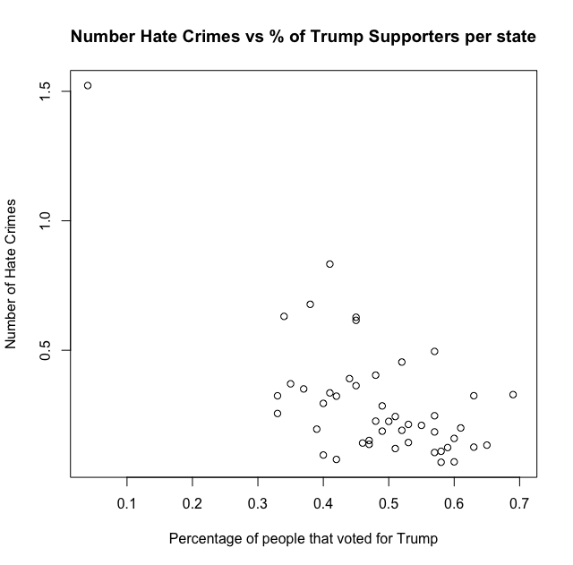

Note: The number of hate crimes is a ratio of hate crimes/per 100,000 people

It seems like there might be a correlation, however, there is not a direct visual conclusion I can gather from the graph, so I decided to transform the data by splitting the percentage of Trump Supporters into two categories “low” and “high”. I found the mean number of hate crimes to be 0.38 for states with “Low” Trump Supporters and 0.20 for states with “High” Trump Supporters. This is a surprising conclusion because it contradicts Smollett’s and other people’s perception that a state with high Trump support would have more hate crimes.

I formed an alternative hypothesis that the “Mean of the number of hate crimes in states with low Trump Supporters is greater than the mean of the number of hate crimes in states with high Trump Supporters.” To support the accuracy of my conclusion, I did a Permutation Test to find the p-value and found it to be **0.0035**. This suggests that the pattern I found was not randomly generated.

There is a lot of other investigation that can be done to see what affects hate crimes. For example, I also found that the disparity of the median income in the states also affects the number of hate crimes. Once again, I divided the median income into income below $40,000, between $40-50,000 etc.



I found that the higher incomes generally have a higher number of hate crimes. I formed the alternative hypothesis that the “Mean of the number of hate crimes in states with high median income of over $60,000 is greater than the mean of the number of hate crimes in states with less than $40,000 income.” The p-value needs to be lower than 0.05/(4C2) = 0.08. I found the p-value to be **5*10-4** suggesting this is a strong correlation. The higher median household income and higher hate crimes trend could be because of a possible disparity of income in those states.

In conclusion, this data gives valuable insight into hate crime statistics and is relevant in modern day society as it objectively debunks the notion of the negative correlation between MAGA supporters and hate crimes.